|  |  |  |
| --- | --- | --- |
|  | **2, LEBUH ACHEH, GEORGE TOWN**  **10300 GEORGE TOWN**  **PULAU PINANG**  **INFORMATION SHEET** | |
| **PROGRAM’S CODE & NAME** | J620-002-4:2020 FRONT-END SOFTWARE DEVELOPMENT | |
| **LEVEL** | FOUR (4) | |
| **COMPETENCY UNIT NO. AND TITLE** | J620-002-4:2020-C0: MOBILE APPLICATION WITH THIRD PARTY API DEVELOPMENT | |
| **WORK ACTIVITIES NO. AND STATEMENT** | 1. CREATE MOBILE APP DESIGN MOCK-UP ELEMENTS. 2. **PLAN MOBILE APP DESIGN STRUCTURE.** 3. TRANSFORM MOCK-UP TO MOBILE APP. 4. INTEGRATE MOBILE APP WITH DATA SOURCE. 5. VERIFY SUCCESSFUL API INTEGRATION 6. VERIFY DEVELOPED MOBILE APP. 7. VERIFY MOBILE APP ACCESSIBLE GLOBALLY. | |
| **CODE NO.** | J620-002-4:2020-C04/IS(3/15) | Page: 1 of 22 |

**TITLE**:

**USER INTERFACE GUIDELINES AND DESIGN TOOLS**

**PURPOSE**:

This information sheet is intended to provide insight and knowledge to trainees with regards to the fundamentals of user interface guidelines and design tools.

**INFORMATION:**

This information sheet provides useful notes and explanations on user interface guidelines and design tools.

Generally, User Interface guidelines are subjective depending on the environment and platform the mobile application is running on. Thus, the majority of platform providers came out with their own guidelines for developers to refer to when designing mobile applications that run specifically on the platform. For example, Apple has Human Interface guidelines for applications running on Apple devices and Android has Material Design guidelines for Android applications.

All these guidelines lay out the foundation on how to use certain UI elements and components in the application that runs on its intended platform. The intention is that the apps developed by developers can be consistent and cohesive with the platform. Which in the end of the day, delivers a good experience to the end users?

# **MATERIAL DESIGN**

Material design is a design language developed by Google in 2014. It is a visual language that synthesizes those classic principles of good design with the innovation of technology and science. It is a single system which acts as the unified resource among the devices of different sizes like a laptop, mobile devices, etc. Material Design proffers certain design standards for developing applications across Android, web, and iOS devices.

The material design UI and the material design app are also symbolic of Google’s efforts to take this further towards designing an interface and design language that systematically takes care of multiple obstacles faced by designers. The material design also comes with comprehensive guidelines on every aspect of the design process subsuming animation, sizes of buttons and even the placements.

Material starts with mobile but extends to any other device. It is rooted in a few principles:

* Realistic visual cues: The design is grounded in reality and actually inspired by design with paper and ink.
* Bold, graphic, and intentional: Fundamental design techniques drive the visuals. Typography, grids, space, scale, colour and imagery guide the entire design. Elements that live in defined type choices are a clear hierarchy. Colour and type choices are bold & deliberate.
* Motion provides meaning: Animation is the best part of the material design as they do not interrupt the user-experience in any way. Animation strengthens the fact that the user is a prime mover. Primary user actions are inflection points that initiate motion, transforming the whole design. Motion cascades from touch points and the visual feedback feels really connected to what users have done. Animation makes the user experience more natural and immersive.

## Colour

The material design comprises a remarkable collection of colours that can be made use by the designers from applying them to their user-interface (UI). Material Design's colour tool can also measure the accessibility level of the colour aggregate which will make the look better than the usual.

Moreover, the material design colour system employs an established approach to applying colour to your UI (user interface). Colour in material design is inspired by hues juxtaposed with muted environments, deep shadows, and bright highlights.

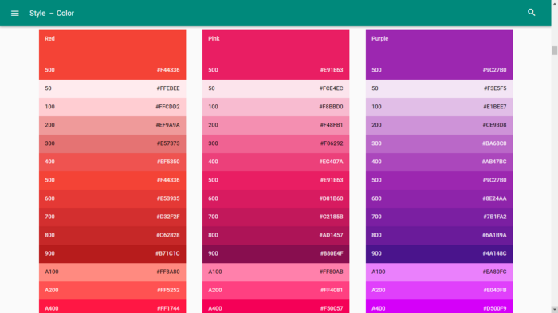

Figure 1: Material Design Colour Tools

## Iconography

Material design classifies icons as two sets, one is Product Icons which are bold, simple, and friendly. They communicate the core-idea and the intent of the product. The Second is System icons represent a command, file, device, directory, or common actions. Sizing followed for Product icons are 48 dp and system icons are 24 dp.

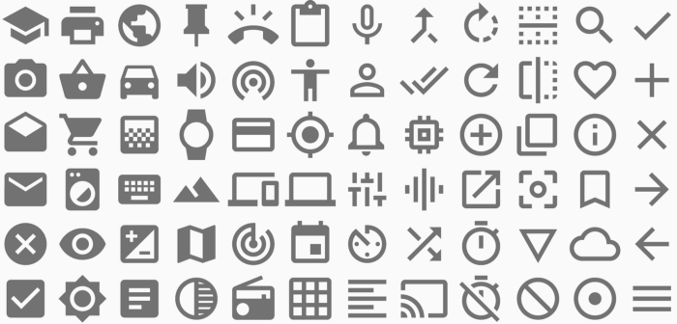

Figure 2: System Icons collection from Material Design Docs by Google

## Typography

Roboto and Noto are the standard typefaces on Android and Chrome. It has been clearly polished to handle the cross-platform usage. Concise and clear text makes the user-interface more usable. Material design provides clear guidelines to handle the writing for different UI elements.

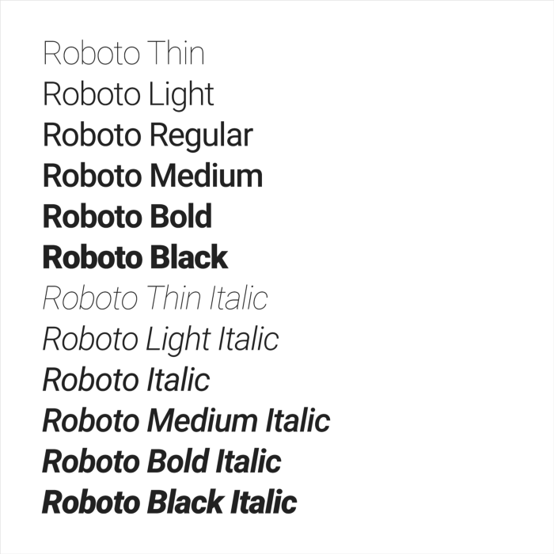

Figure 3: Material Design’s Robot Typeface Variants

## Layout

Layout in material design is based on the principles of print-based design. It uses some tools like baseline grids and structural templates to improve the consistency across the environments. These layouts are capable of creating the scalable apps as they can fit to any screen sizes. The Material Design layout grid is made up of three elements: columns, gutters, and margins.

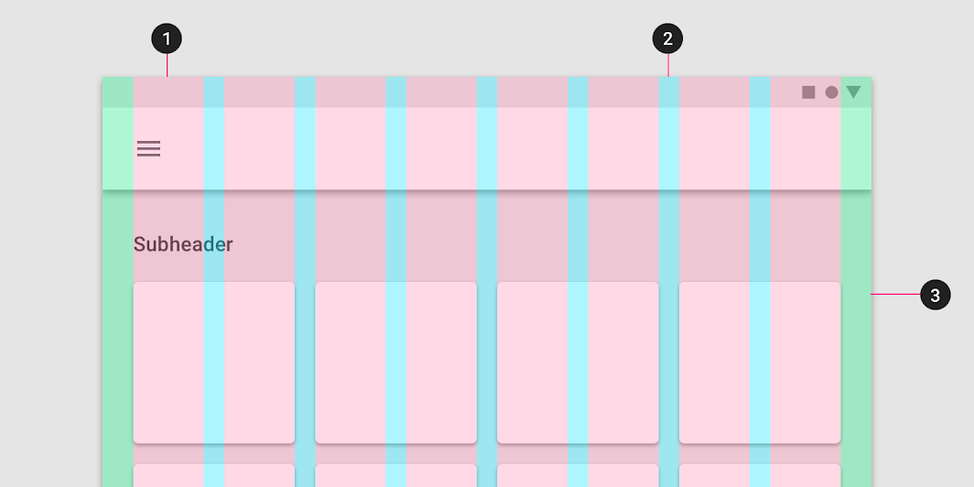

Figure 4: Material Design Layout Example

Table 1: Material Design Layout’s Elements

|  |  |  |
| --- | --- | --- |
| No | Elements | Details |
| 1 | Columns | Content is placed in the areas of the screen that contain columns. Column width is defined using percentages, rather than fixed values, to allow content to flexibly adapt to any screen size. The number of columns displayed in the grid is determined by the breakpoint range (a range of predetermined screen sizes) at which a screen is viewed, whether it is a breakpoint for mobile, tablet, or another size. |
| 2 | Gutters | Gutters are the spaces between columns. They help separate content. Gutter widths are fixed values at each breakpoint range. To better adapt to the screen, gutter width can change at different breakpoints. Wider gutters are more appropriate for larger screens, as they create more whitespace between columns. |
| 3 | Margins | Margins are the space between content and the left and right edges of the screen. Margin widths are defined as fixed values at each breakpoint range. To better adapt to the screen, the margin width can change at different breakpoints. Wider margins are more appropriate for larger screens, as they create more whitespace around the perimeter of content. |

## Components

All the elements in Material Design are detailed definitions. Here are some of the components that are present in the material design:

Table 2: Material Design’s Components

|  |  |
| --- | --- |
| Component | Description |
| Bottom-Navigation Bar | Switch between the top-level views app in a single tap. |
| Bottom-Sheets | They slide up from the bottom to reveal more content. |
| Buttons | Buttons communicate the action that will occur after the user touches it. There are two sets of buttons in material Design, one is flat and other is raised buttons. |
| Cards | It is like an entry point for more information. |
| Chips | Chips contain complex things in small blocks. |
| Dialogs | Dialogs contains specific information about the single or multiple tasks to be performed. Alerts , simple Dialog , simple menus are dialog types. |
| Dividers | It is vertical rule which groups the content in page-layout or list. |
| Expansion Panels | It allows edit the content. It can be either standalone or can combine with card. |
| List | List are made of the continuous columns of each rows. Each row contains the tile and primary action are filled in the tile and supplemental actions are represented with image or text. |
| Menus | They emerge from buttons which are used to choose the action or option. |
| Progress and Activity | It is a visual indication when the app is loading the content. |
| Sliders | Select the value from the range of values by moving the slider thumb. |
| Snack bars and Toast | They provide the feedback in the form of the message after the execution of operation. It can be either success or failure feedback. |
| Tabs | Switch between different views. |
| Tooltips | Tooltips are text-labels that appear when the user hovers over the particular elements. |

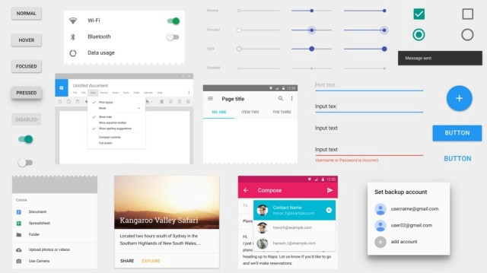

Figure 5: Various Components In Material Design

# **HUMAN INTERFACE**

Human Interface is Apple’s User Interface guideline across its product line such as MacOS, iPhone, tvOS and watchOS. Here will be focusing on the iOS design theme. There are 3 primary themes differentiate iOS from other platforms:

* Clarity: Throughout the system, text is legible at every size, icons are precise and lucid, adornments are subtle and appropriate, and a sharpened focus on functionality motivates the design. Negative space, colour, fonts, graphics, and interface elements subtly highlight important content and convey interactivity.
* Deference: Fluid motion and a crisp, beautiful interface help people understand and interact with content while never competing with it. Content typically fills the entire screen, while translucency and blurring often hint at more. Minimal use of bezels, gradients, and drop shadows keep the interface light and airy, while ensuring that content is paramount.
* Depth: Distinct visual layers and realistic motion convey hierarchy, impart vitality, and facilitate understanding. Touch and discoverability heighten delight and enable access to functionality and additional content without losing context. Transitions provide a sense of depth as you navigate through content.

## Colour

Colour is a great way to impart vitality, provide visual continuity, communicate status information, give feedback in response to user actions, and help people visualize data. There are several key points to look into:

1. Use colour judiciously for communication. The power of colour to call attention to important information is heightened when used sparingly. For example, a red triangle that warns people of a critical problem becomes less effective when red is used elsewhere in an app for noncritical reasons.
2. Use complementary colours throughout your app. The colours in your app should work well together, not conflict or distract. If pastels are essential to your app’s style, for example, use a coordinating set of pastels.
3. In general, choose a limited colour palette that coordinates with your app logo. Subtle use of colour is a great way to communicate your brand.
4. Consider choosing a tint colour to indicate interactivity throughout your app. In Notes, interactive elements are yellow. In Calendar, interactive elements are red. If you define a tint colour that denotes interactivity, make sure other colours do not compete with it.
5. Provide two versions of your tint colour to make sure it looks good in both light and dark modes. When you use a system colour for your tint color, you get automatic support for high contrast.
6. Avoid using the same colour for interactive and noninteractive elements. If interactive and noninteractive elements have the same color, it is hard for people to know where to tap.
7. Consider how artwork and translucency affect nearby colors. Variations in artwork sometimes warrant changes to nearby colours in order to maintain visual continuity and prevent interface elements from becoming overpowering or underwhelming. Maps, for example, displays a light colour scheme when using map mode but switches to a dark colour scheme when satellite mode is activated. Colours can also appear different when placed behind a translucent element, or when applied to a translucent element, such as a toolbar.
8. Test your app’s colour scheme under a variety of lighting conditions. Lighting varies significantly both indoors and outdoors, based on room ambiance, time of day, the weather, and more. Colours you see on your computer will not always look the same when your app is used in the real world. Always preview your app under multiple lighting conditions, including outdoors on a sunny day, to see how colours appear. If necessary, adjust colours to provide the best possible viewing experience in the majority of use cases.
9. Consider how the True Tone display affects color. The True Tone display uses ambient light sensors to automatically adjust the white point of the display to adapt to the lighting conditions of the current environment. Apps that focus primarily on reading, photos, video, and gaming can strengthen or weaken this effect by specifying a white point adaptivity style.
10. Consider how your use of colour might be perceived in other countries and cultures. In some cultures, for example, red communicates danger. In others, red has positive connotations. Make sure the colours in your app send the appropriate message.
11. Avoid using colours that make it hard for people to perceive content in your app. For example, colour-blind people might not be able to distinguish some colour combinations, and insufficient contrast can cause icons and text to blend with the background and make content hard to read. For guidance, see Colour and Contrast.

## Iconography

Every app needs a beautiful and memorable icon that attracts attention in the App Store and stands out on the Home screen. The icon is the first opportunity to communicate, at a glance, the app’s purpose. It also appears throughout the system, such as in Settings and search results. Following the guidelines designing app icon:

1. Embrace simplicity. Find a single element that captures the essence of your app and express that element in a simple, unique shape. Add details cautiously. If an icon’s content or shape is overly complex, the details can be hard to discern, especially at smaller sizes.
2. Provide a single focus point. Design an icon with a single, cantered point that immediately captures attention and clearly identifies your app.
3. Design a recognizable icon. People should not have to analyse the icon to figure out what it represents. For example, the Mail app icon uses an envelope, which is universally associated with mail. Take time to design a beautiful and engaging abstract icon that artistically represents your app’s purpose.
4. Keep the background simple and avoid transparency. Make sure your icon is opaque, and do not clutter the background. Give it a simple background so it does not overpower other app icons nearby. You do not need to fill the entire icon with content.
5. Use words only when they are essential or part of a logo. An app’s name appears below its icon on the Home screen. Do not include nonessential words that repeat the name or tell people what to do with your app, like "Watch" or "Play." If your design includes any text, emphasize words that relate to the actual content your app offers.
6. Do not include photos, screenshots, or interface elements. Photographic details can be very hard to see at small sizes. Screenshots are too complex for an app icon and do not generally help communicate your app’s purpose. Interface elements in an icon are misleading and confusing.
7. Do not use replicas of Apple hardware products. Apple products are copyrighted and cannot be reproduced in your icons or images. In general, avoid displaying replicas of devices, because hardware designs tend to change frequently and can make your icon look dated.
8. Do not place your app icon throughout the interface. It can be confusing to see an icon used for different purposes throughout an app. Instead, consider incorporating your icon’s colour scheme.
9. Test your icon against different wallpapers. You cannot predict which wallpaper people will choose for their Home screen, so do not just test your app against a light or dark color. See how it looks over different photos. Try it on an actual device with a dynamic background that changes perspective as the device moves.
10. Keep icon corners square. The system applies a mask that rounds icon corners automatically.

## Typography

Apple provides two type families you can use in your iOS apps.

Table 3: Fonts Details in iOS Human Interaction

|  |  |  |
| --- | --- | --- |
| Font Family | Typeface | Details |
| Sans Serif | San Francisco | San Francisco is a sans serif type family that includes SF Pro, SF Pro Rounded, SF Mono, SF Compact, and SF Compact Rounded. SF Pro is the system font in iOS, macOS, and tvOS; SF Compact is the system font in watchOS. Designed to match the visual clarity of the platform UIs, the system fonts are legible and neutral.  The phrase 'The quick brown fox jumps over the lazy dog.' shown in San Francisco Pro. |
| Serif | New York | New York is a serif typeface that provides a unique tone designed to complement the SF fonts. NY works as well in a graphic display context (at large sizes) as it does in a reading context (at text sizes).  The phrase 'The quick brown fox jumps over the lazy dog.' shown in New York. |

Beginning in iOS 14, the system provides the San Francisco and New York fonts in the variable font format. This format combines different font styles together in one file and supports interpolation between styles to create intermediate ones. With interpolation, typefaces can adapt to all sizes while appearing specifically designed for each size.

Interpolation also enables optical sizing, which refers to the creation of different typographic designs to fit different sizes. Both San Francisco and New York provide specific optical size variants to ensure that text can look great at any size: Text and Display for SF Pro and SF Compact, and Small, Medium, Large, and Extra Large for New York. In iOS 14 and later, the system fonts support dynamic optical sizes, merging the discrete optical sizes like Text and Display into a single, continuous design. This design allows each glyph or letterform to be interpolated to produce a structure that is precisely adapted to the point size.

Because SF Pro and NY are compatible, there are many ways you can incorporate typographic contrast and diversity into your iOS interfaces while maintaining a consistent look and feel. For example, using both typefaces can help you create stronger visual hierarchies or highlight semantic differences in content.

Apple-designed typefaces support an extensive range of weights, sizes, styles, and languages, so you can design comfortable and beautiful reading experiences throughout your app. When you use text styles with the system fonts, you also get support for Dynamic Type and the larger accessibility type sizes, which let people choose the text size that works for them. For specific values, see Dynamic Type Sizes and Larger Accessibility Type Sizes. Size information, including tracking values, is also available in the Sketch, Photoshop, and Adobe XD Apple Design Resources for iOS.

## Layout

Layout guides define rectangular regions that do not actually appear visibly onscreen, but aid with the positioning, alignment, and spacing of content. The system includes predefined layout guides that make it easy to apply standard margins around content and restrict the width of text for optimal readability. You can also define custom layout guides.

Adhere to the safe area and layout margins defined by UIKit. These layout guides ensure appropriate settings based on the device and context. The safe area also prevents content from underlapping the status bar, navigation bar, toolbar, and tab bar. Standard system-provided views automatically adopt a safe area layout guide.

|  |
| --- |
|  |

Figure 6: iPhone Layout

# **UI DESIGN TOOLS**

There are multiple options in the market for software that help developers and designers to design user interfaces for mobile applications. The primary function of these tools is to build the user interface layout so that the idea of the application will be built is clear and precise. Second, it helps designers to showcase or prototype how the interaction in the application behaves and looks like. Adobe XD, Figma and Sketch are among well-known user interface tools out there.

## Adobe XD

Adobe XD is a vector-based user experience design tool for web apps and mobile apps, developed and published by Adobe Inc. It is available for macOS and Windows, although there are versions for iOS and Android to help preview the result of work directly on mobile devices. Adobe XD supports website wireframing and creating click-through prototypes.

Adobe XD creates user interfaces for mobile and web apps. Many features in XD were previously either hard to use or non-existent in other Adobe applications like Illustrator or Photoshop. Such as:

1. Repeat grid: Helps creating a grid of repeating items such as lists, and photo galleries.
2. Prototype and animation: Create animated prototypes through linking artboards. These prototypes can be previewed on supported mobile devices.
3. Interoperability: XD supports and can open files from Illustrator, Photoshop, Photoshop Sketch, and After Effects. In addition to the Adobe Creative Cloud, XD can also connect to other tools and services such as Slack and Microsoft Teams to collaborate. XD is also able to auto adjust and move smoothly from macOS to Windows. For security, prototypes can be sent with password protections to ensure full disclosure.[6]
4. Voice design: Apps can be designed using voice commands. In addition, what users create for smart assistants can be previewed as well.
5. Components: Users can create components (previously known as symbols) to create logos, buttons and other assets for reuse. Their appearance can change with the context where they are used.
6. Responsive resize: Responsive resize automatically adjusts and sizes pictures and other objects on the artboards. This allows the user to have their content automatically adjusted for different screens for different sized platforms such as mobile phones and PC's.
7. Plugins: XD is compatible with custom plugins that add additional features and uses. Plugins range from design to functionality, automation, and animation.

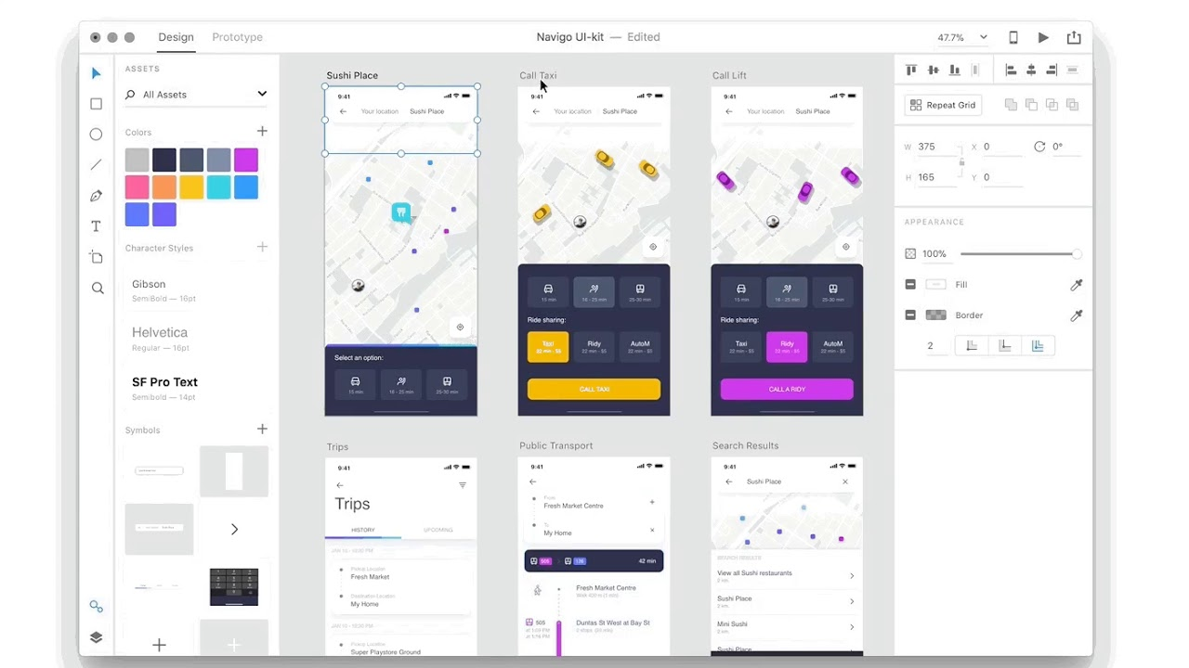

Figure 7: Adobe XD User Interface

## Figma

Figma is a vector graphics editor and prototyping tool which is primarily web-based, with additional offline features enabled by desktop applications for macOS and Windows. The Figma Mirror companion apps for Android and iOS allow viewing Figma prototypes on mobile devices. The feature set of Figma focuses on use in user interface and user experience design, with an emphasis on real-time collaboration.

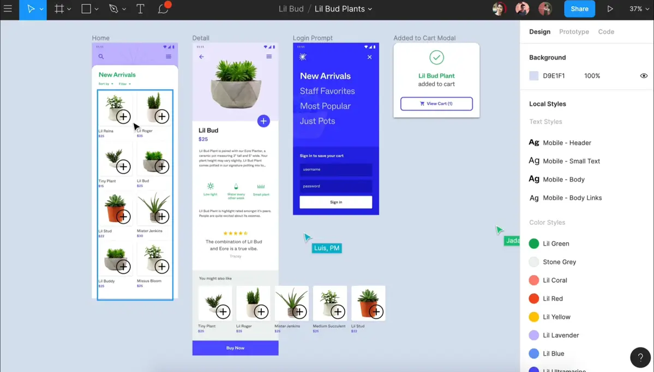

Figure 8: Figma User Interface

## Sketch

Sketch is used primarily for designing the UI and UX of mobile apps and web. The files designed in Sketch are saved in its own sketch file format, though sketch files can be opened in Adobe Illustrator, Adobe Photoshop, and other programs. The designs can also be saved in the popular PNG, JPG, SVG, PDF, TIFF, WebP, etc., formats. The designs created in Sketch are utilized by app engineers to design mobile apps and by website developers convert designs into websites.

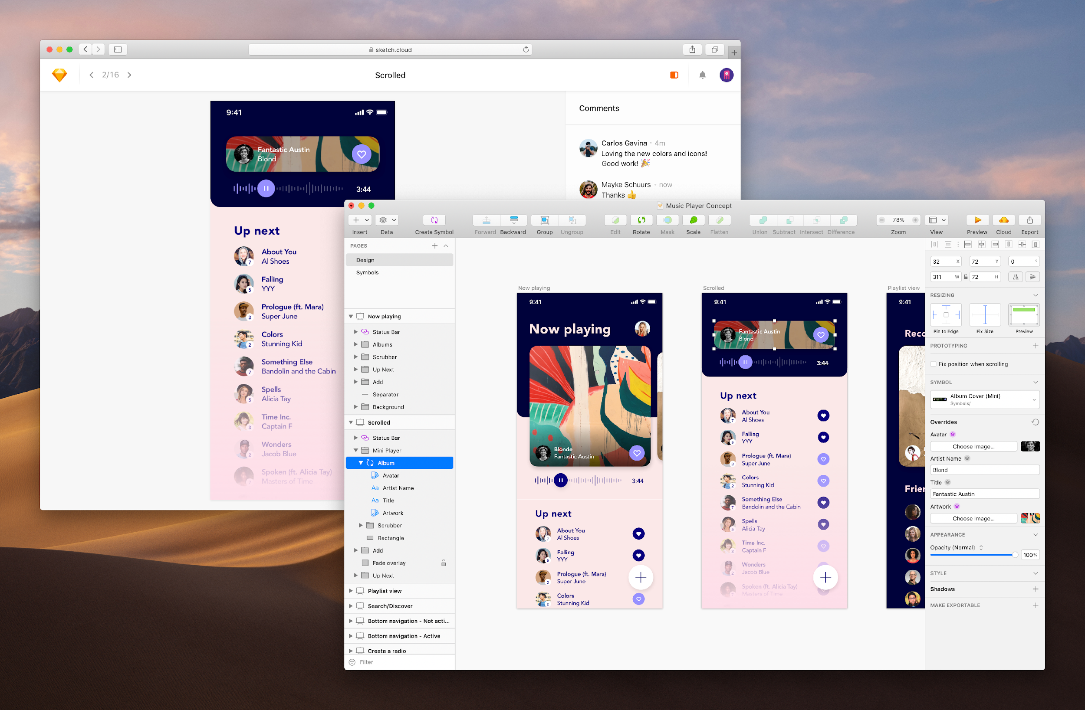

Figure 9: Sketch User Interface

**QUESTIONS:**

1. List out the major user interface guidelines used to design mobile applications.

**Answer:**

* 1. **Material Design by Google.**
  2. **Human Interaction by Apple.**

1. Explain the principles of Material Design.

**Answer:**

* 1. **Realistic visual cues: The design is grounded in reality and actually inspired by design with paper and ink.**
  2. **Bold, graphic, and intentional: Fundamental design techniques drive the visuals. Typography, grids, space, scale, colour and imagery guide the entire design. Elements that live in defined type choices are a clear hierarchy. Colour and type choices are bold & deliberate.**
  3. **Motion provides meaning: Animation is the best part of the material design as they do not interrupt the user-experience in any way. Animation strengthens the fact that the user is a prime mover. Primary user actions are inflection points that initiate motion, transforming the whole design.**

1. What are the standard typefaces on Android and Chrome?

**Answer:**

* 1. **Roboto.**
  2. **Noto.**

1. Explain the element columns in Material Design’s layout:

**Answer:**

* 1. **Content is placed in the areas of the screen that contain columns. Column width is defined using percentages, rather than fixed values, to allow content to flexibly adapt to any screen size. The number of columns displayed in the grid is determined by the breakpoint range (a range of predetermined screen sizes) at which a screen is viewed, whether it is a breakpoint for mobile, tablet, or another size.**

1. Describe the gutters element in Material Design’s layout:

**Answer:**

* 1. **Gutters are the spaces between columns. They help separate content. Gutter widths are fixed values at each breakpoint range. To better adapt to the screen, gutter width can change at different breakpoints. Wider gutters are more appropriate for larger screens, as they create more whitespace between columns.**

1. What is the component in Material Design that fits the description: It is a vertical rule which groups the content in page-layout or list.

**Answer:**

**Dividers.**

1. What are 3 primary themes differentiate iOS from other platforms?

**Answer:**

1. **Clarity: Throughout the system, text is legible at every size, icons are precise and lucid, adornments are subtle and appropriate, and a sharpened focus on functionality motivates the design. Negative space, color, fonts, graphics, and interface elements subtly highlight important content and convey interactivity.**
2. **Deference: Fluid motion and a crisp, beautiful interface help people understand and interact with content while never competing with it. Content typically fills the entire screen, while translucency and blurring often hint at more. Minimal use of bezels, gradients, and drop shadows keep the interface light and airy, while ensuring that content is paramount.**
3. **Depth: Distinct visual layers and realistic motion convey hierarchy, impart vitality, and facilitate understanding. Touch and discoverability heighten delight and enable access to functionality and additional content without losing context. Transitions provide a sense of depth as you navigate through content.**
4. What are the standard typefaces on iOS apps?

**Answer:**

1. **San Francisco**
2. **New York**
3. What are 3 major user interface tools in the market?

**Answer:**

1. **Adobe XD**
2. **Figma**
3. **Sketch**
4. What are 3 principles to design iconography in Human Interaction guideline?

**Answer:**

1. **Embrace simplicity. Find a single element that captures the essence of your app and express that element in a simple, unique shape. Add details cautiously. If an icon’s content or shape is overly complex, the details can be hard to discern, especially at smaller sizes.**
2. **Provide a single focus point. Design an icon with a single, cantered point that immediately captures attention and clearly identifies your app.**
3. **Design a recognizable icon. People should not have to analyse the icon to figure out what it represents. For example, the Mail app icon uses an envelope, which is universally associated with mail. Take time to design a beautiful and engaging abstract icon that artistically represents your app’s purpose.**

**REFERENCE:**

1. <https://paradisetechsoftsolutions7.medium.com/a-beginners-guide-to-material-design-material-design-tutorial-4f02d0e1002e>
2. <https://material.io/design/iconography/system-icons.html#color>
3. [https://material.io/design/layout/understanding-layout.html#](https://material.io/design/layout/understanding-layout.html)
4. <https://material.io/design/color/the-color-system.html#color-usage-and-palettes>
5. <https://developer.apple.com/design/human-interface-guidelines/ios/overview/themes/>
6. <https://developer.apple.com/design/human-interface-guidelines/ios/visual-design/adaptivity-and-layout/>
7. <https://developer.apple.com/design/human-interface-guidelines/ios/visual-design/typography/>
8. <https://developer.apple.com/design/human-interface-guidelines/ios/icons-and-images/app-icon/>
9. <https://en.wikipedia.org/wiki/Adobe_XD>
10. <https://en.wikipedia.org/wiki/Figma_(software)>
11. <https://en.wikipedia.org/wiki/Sketch_(software)>